INDEX

- Raspberry System Upgradation
- Python installation
- PostgreSQL Installation.
- Docker Installation
- Django Project Setup
  - Django Project Setup using Local Environment.
  - Django Project Setup using Docker Environment.
- Modbus installation
- Run main code

- Raspberry-Pi System Upgradation
Commands:
- sudo apt-get update
- sudo apt-get upgrade

Python installation

Installation procedure for python (version 3.9)
- Open Terminal Window and execute the following commands
- wget https://www.python.org/ftp/python/3.9.5/Python-3.9.5.tgz
- tar -zxvf Python-3.9.5.tgz
- cd Python-3.9.5
- ./configure --enable-optimizations
- sudo make altinstall
- cd /usr/bin
- sudo rm python
- sudo ln -s /usr/local/bin/python3.9 python
- python --version
- sudo apt update
- sudo apt upgrade
- python --version
- python3 --version

PostgreSQL Installation

Procedure to install PostgreSQL on Raspberry Pi
- sudo apt update
- sudo apt install postgresql -y
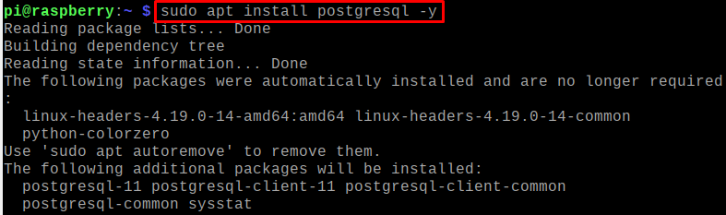
- sudo systemctl status postgresql
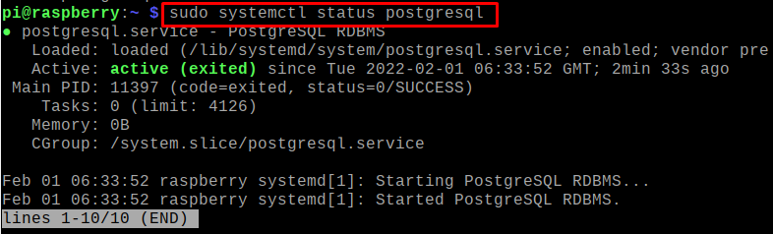
- sudo su postgres
- createuser pi -p --interactive

- psql
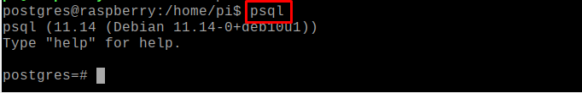
- To exit from the postgres type the command cmd=”\q” press enter and type “exit” and press enter

Docker Installation
Procedure for installation of Docker
- sudo apt update

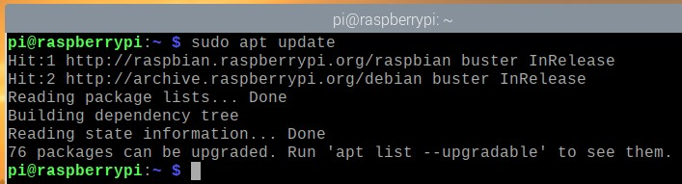
- sudo apt upgrade
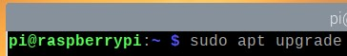
To confirm the upgrade, press Y and then <Enter>.
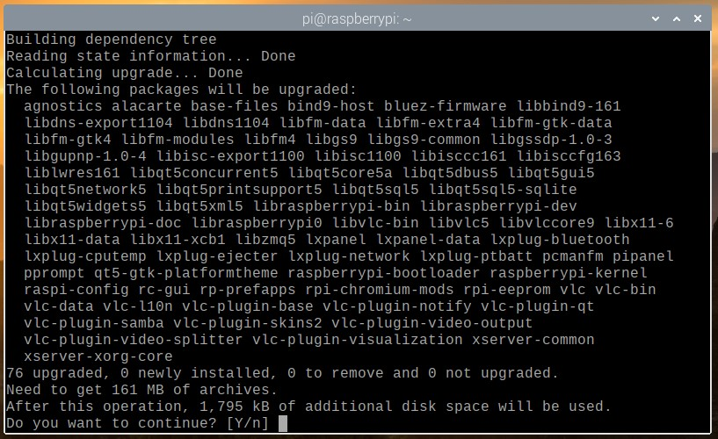

- sudo reboot
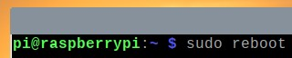
- curl -fsSL https://get.docker.com -o get-docker.sh
- The Docker installation script get-docker.sh should be downloaded to your current working directory.
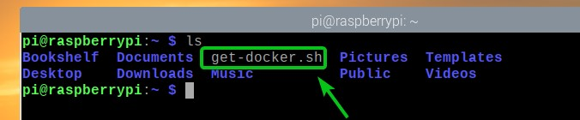
- sudo bash get-docker.sh
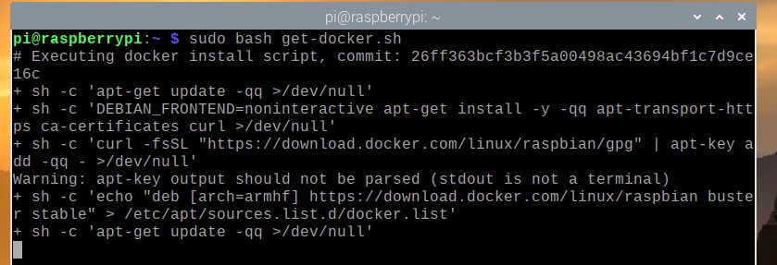
- sudo usermod -aG docker $(raspberry pi user name )
Ex:pi
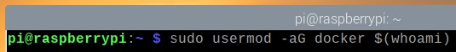
- sudo reboot

- docker version
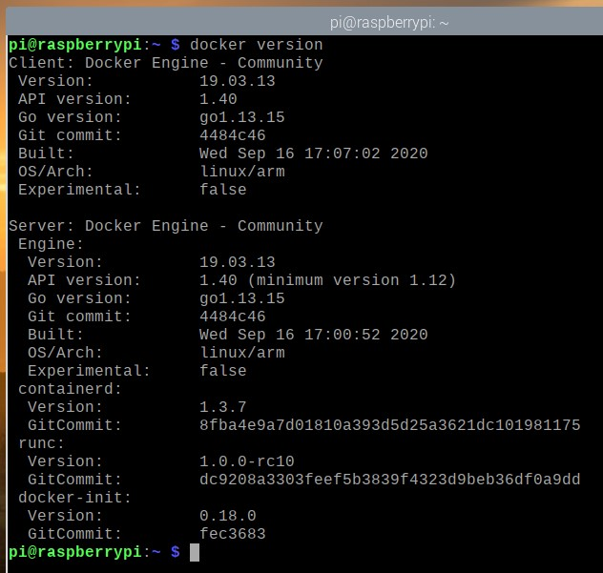
- sudo apt install python3-pip -y
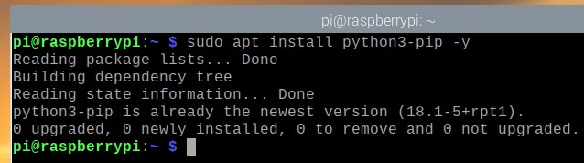
- sudo pip3 install docker-compose
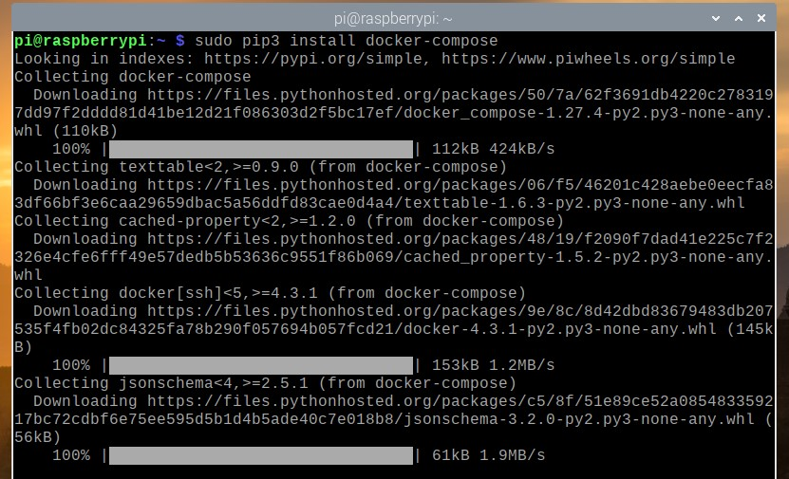

- docker-compose version
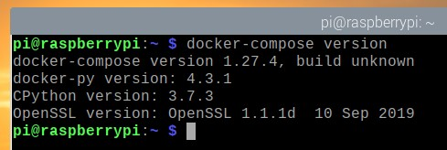
- docker search apache
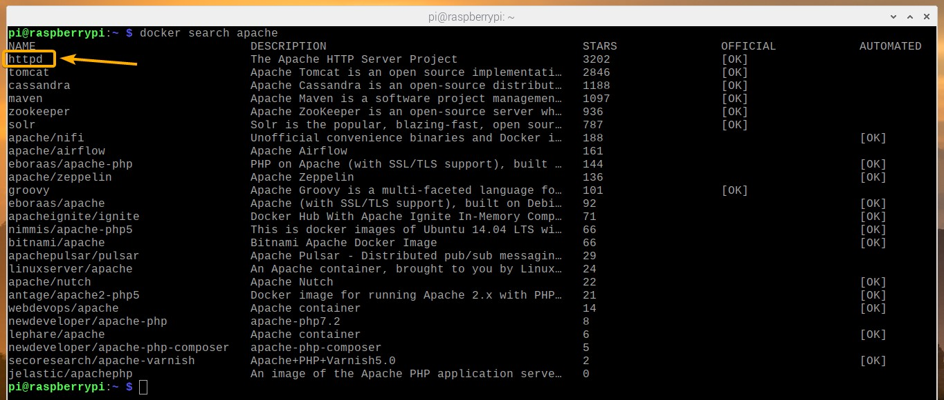
- docker run -d -p 813080:80 httpd
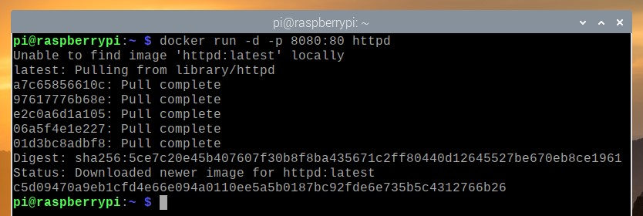
- Check the URL in the web server “http://localhost:8080”
- docker container ls
- docker run -d -p 8081:80 --name webserver2 httpd
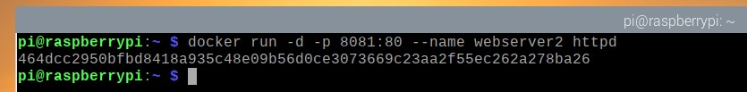
- docker container ls
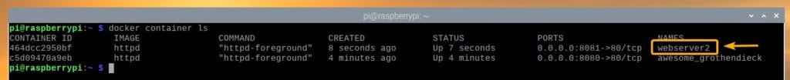
- Check the URL http://localhost:8081.
- docker container stop webserver2
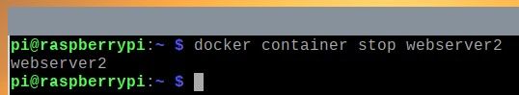
- docker container ls
- docker container stop c5d09470a9eb
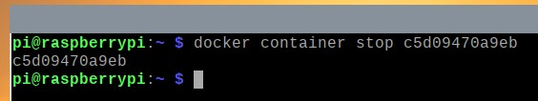

- Django Project Setup
- Django Project Setup using Local Environment

Copy project path on terminal window and run below command
Command:
1. pip install virtualenv
2.python –m virtualenv env or , python –m venv ./env
3. source ./env/bin/activate
4. pip install –r requirements.txt
5. python manage.py makemigrations
6. python manage.py migrate
7. python manage.py createsuperuser
8. python manage.py runserver

- Django Project Setup using Docker Environment.
copy project path on terminal window and run below command
  - command: 1. sudo docker-compose build
- sudo docker-compose up

- To create superuser for webserver
Command: sudo docker exec -it “container id” python manage.py createsuperuser

To find container id run the following command: sudo docker container ls

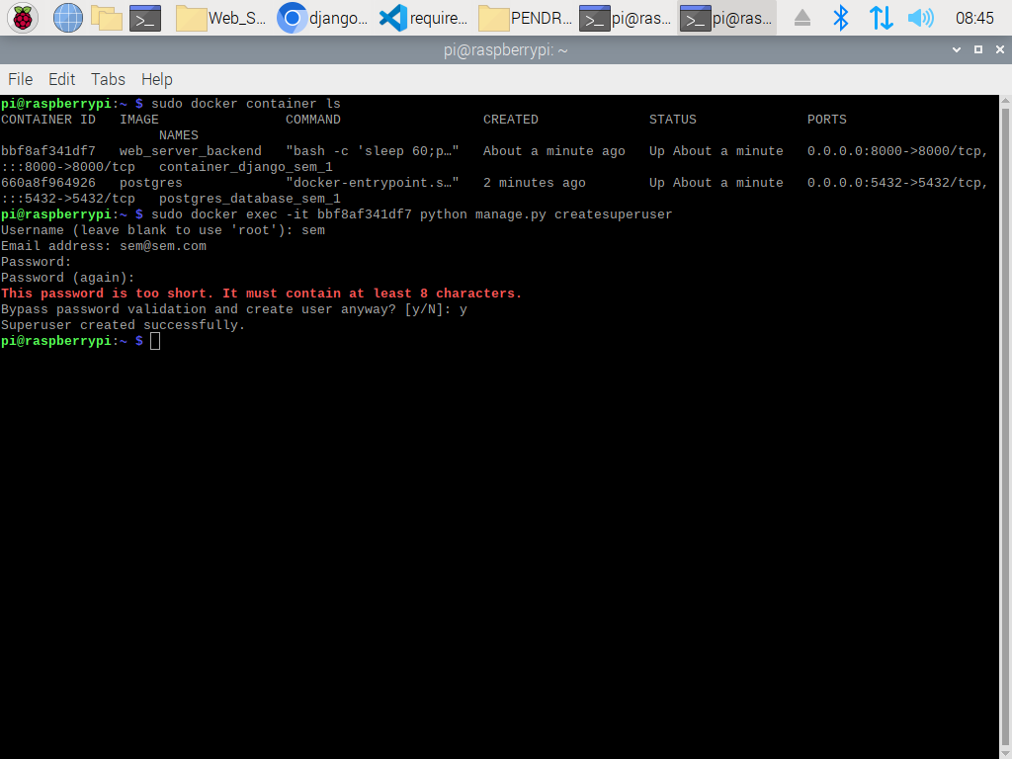

- To open the web server search the following URL in the browser
URL : http://localhost:8000/admin
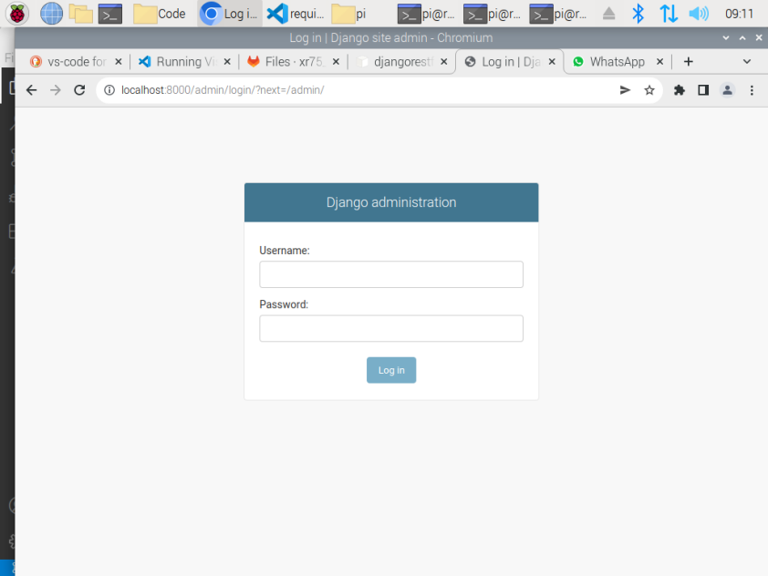
Login using superuser credential as admin or login using user credentials.
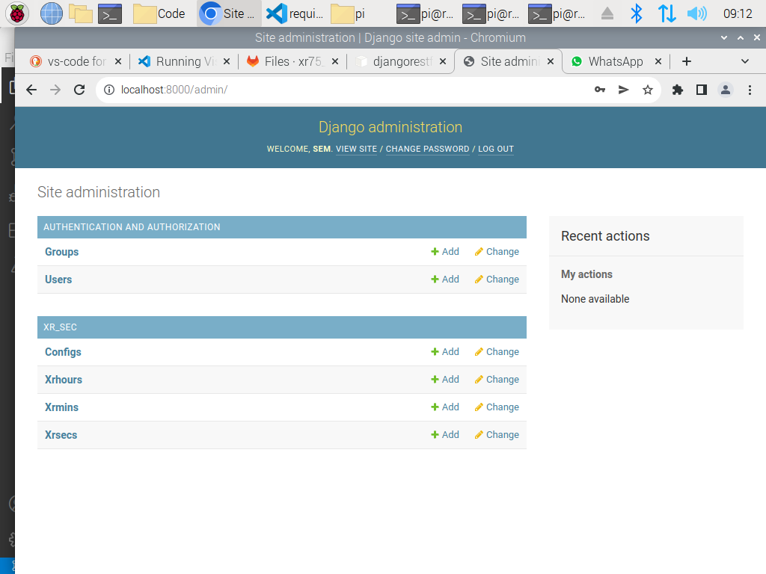

Modbus installation
Procedure to install the pymodbus
Install packages
- Open terminal and use below commands to install packages.
- Use command to install the pymodbus
- Command: pip install pymodbus.
- Other Libraries installation:
- Command : pip install schedule
- Command: pip install psycopg2
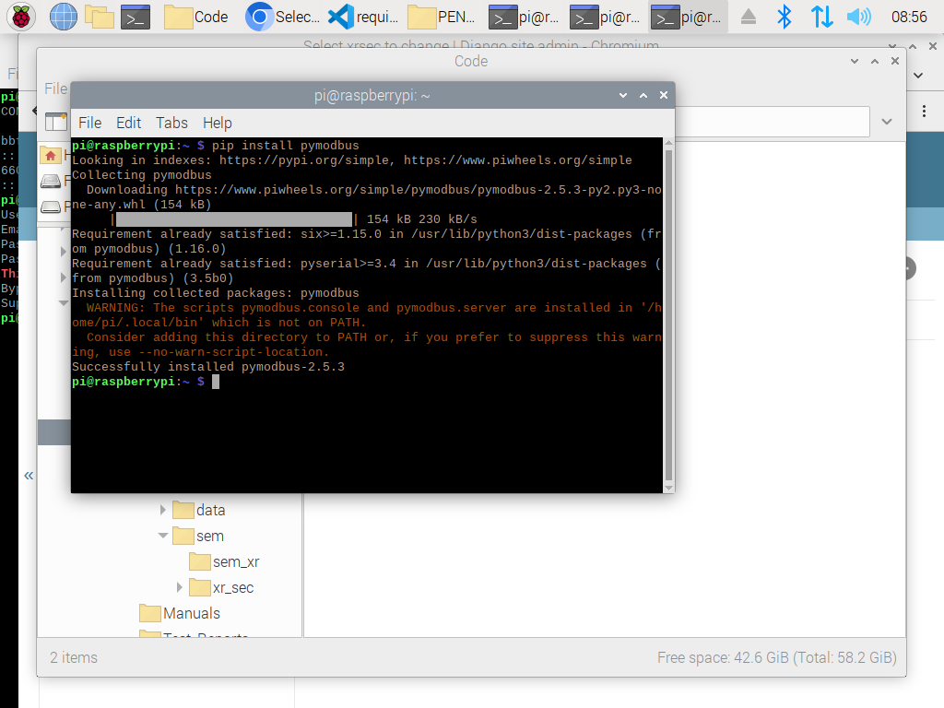

Files to Run
- Copy the code in one directory.
- Open terminal and go to the directory where main.py file is present.
- In terminal window use below command to run the python file.
- Command : python main.py.
- Code runs and wait for the request.

